MODULE -2 [Data Structures and Algorithms]
Question-1: E-Commerce Platform Search Function
Source Code:
using System;
class Program
{ static void Main()
{
string[] products =
{
"Camera",
"Headphones",
"Keyboard",
"Laptop",
"Mobile",
"Monitor",
"Mouse",
"Printer",
"Speaker",
"Tablet"
};
Array.Sort(products);
Console.Write("Enter product name to search: ");
string key = Console.ReadLine();
int left = 0;
int right = products.Length - 1;
bool found = false;
while (left <= right)
{
int mid = (left + right) / 2;
int result = string.Compare(products[mid], key, true);
if (result == 0)
{
Console.WriteLine("Product Found: " + products[mid]);
found = true;
break;
}
else if (result < 0)
{
left = mid + 1;
}
else
{
right = mid - 1;
}
}
if (!found)
{
Console.WriteLine("Product Not Found");
}
}
}
Output:
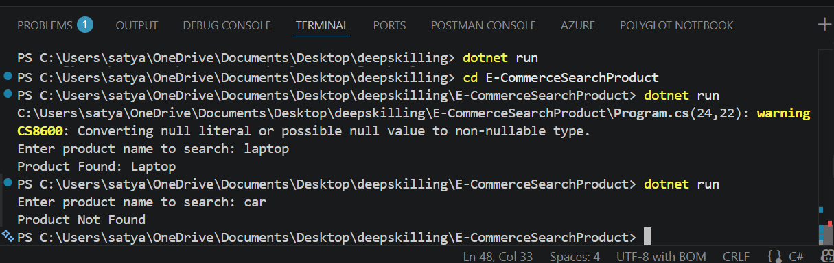

Question 2: Financial Forecasting
Source Code:
using System;
class Program
{
static double Forecast(double amount, double rate, int years)
{
if (years == 0)
return amount;
return Forecast(amount * (1 + rate / 100), rate, years - 1);
}
static void Main()
{
Console.Write("Enter Current Revenue: ");
double revenue = Convert.ToDouble(Console.ReadLine());
Console.Write("Enter Growth Rate (%): ");
double rate = Convert.ToDouble(Console.ReadLine());
Console.Write("Enter Number of Years: ");
int years = Convert.ToInt32(Console.ReadLine());
double future = Forecast(revenue, rate, years);
Console.WriteLine("Predicted Revenue = " + future);
}
}
Output:
